**Answer Key**

**B2-SET B**

**PART B**

**11.**

**A.**

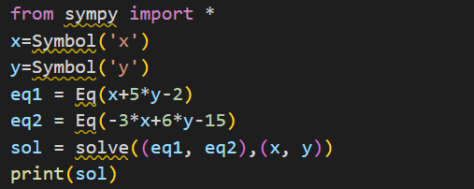

**B.**

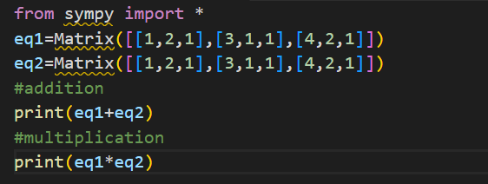

**12.**

**A.**

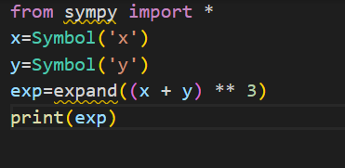

**B.**

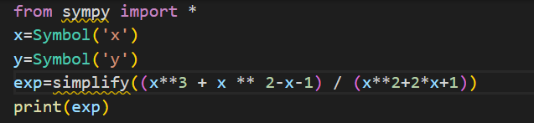

**13.**

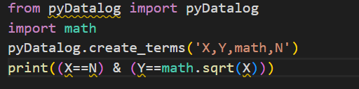

**14.**

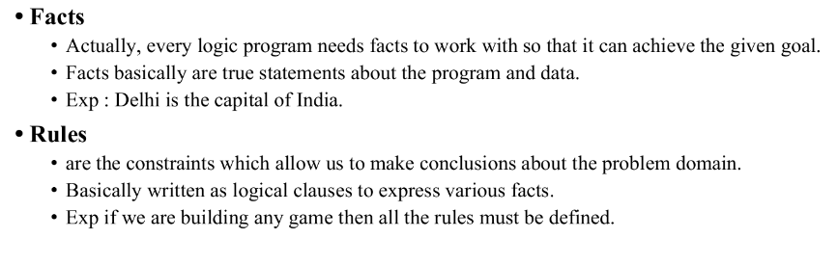

**Advantages of logic paradigm-**

1. **It is very simple.**
2. **It is very Concise and easy to understand and have only one data type .**

**15.**

**Datagram Socket:**

Connectionless channel.

Not dedicated & end-to-end channel between server and client.

Use UDP for data transmission.

Not 100% reliable and may lose data.

Data sent/received order might not be the same.

Don't care or rapid recovering lost/mistaken data.

**Stream Socket:**

Connection-Oriented communication.

Dedicated & end-to-end channel between server and client.

Use TCP protocol for data transmission.

Reliable and Lossless.

Data sent/received in the similar order.

Long time for recovering lost/mistaken data

**16. A. {0,1}**

**B. q0**

**C. q0, q1**

**D. q0**

**E.** Transition Function-

|  |  |  |
| --- | --- | --- |
| States/Alphabets | 0 | 1 |
| Q0 | Q0 | Q1 |
| Q1 | Q2 | Q1 |
| Q2 | Q2 | Q2 |

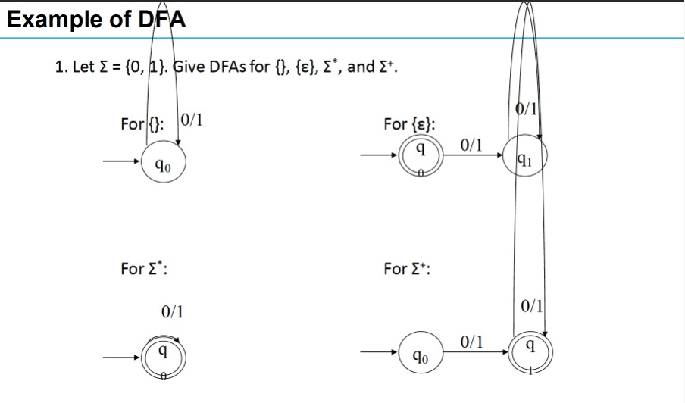

1**7. SERVER SIDE-**

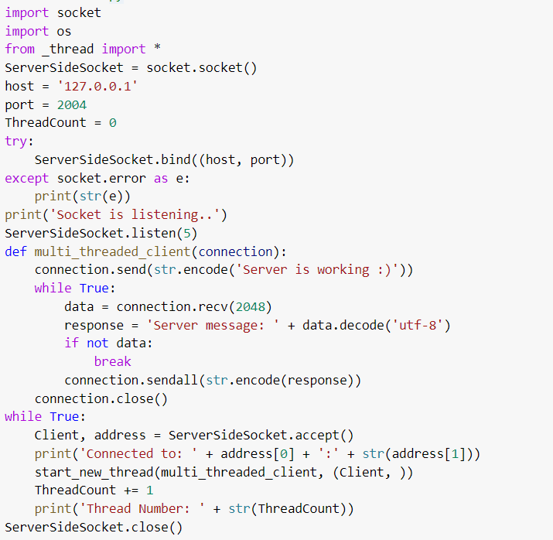

**CLIENT SIDE-**

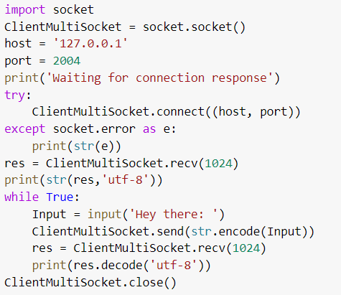

**18.**

**A.**

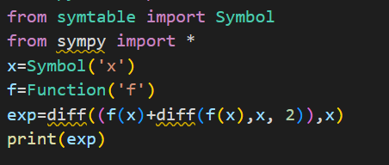

**B.**

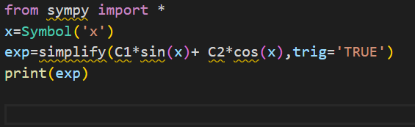

**C.**

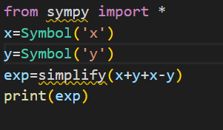

**D.**

* **Cos(x)**
* **-4sin(2*x)**

**19.**

**A.**

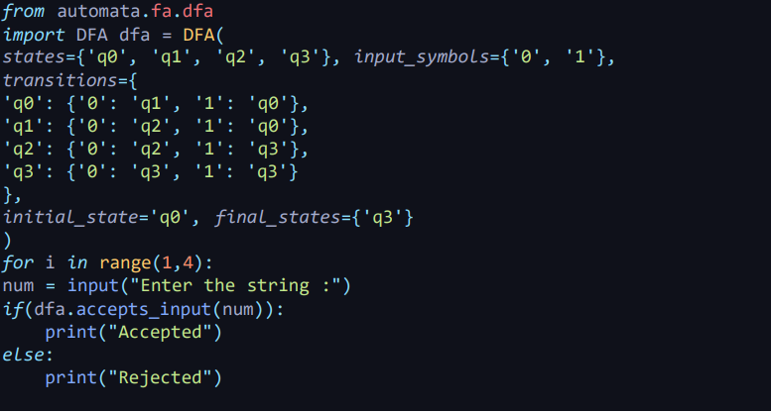

**B.**

